Project Delivery Methodology (PDM)

**TECHNICAL ARCHITECTURE**

**BIT Project**

**VERSION: 1.0 REVISION DATE:11/02/2018**

Approval of the Technical Architecture indicates an understanding of the purpose and content described in this deliverable. By signing this deliverable, each individual agrees with the content contained in this deliverable.

|  |  |  |  |
| --- | --- | --- | --- |
| **Approver Name** | **Title** | **Signature** | **Date** |
|  |  |  |  |
|  |  |  |  |
|  |  |  |  |
|  |  |  |  |
|  |  |  |  |

**Contents**

**Section 1 DOCUMENT SCOPE …………………………..…………………………………………...3**

**Section 2 OVERALL TECHNICAL ARCHITECTURE ……………………………………………...3**

2.1 System Architecture Context Diagram…………………………………………………….3

2.2 System Architecture Mod...………………………………………………………………...4

2.2.1 Overall Architectural Considerations ...……………………………………………….4

2.3 System Architecture Component Definitions .…………………………………………....5

2.3.1 System Architecture Component A ………………………………………………….5

**Section 3 SYSTEM ARCHITECTURE DESIGN ……………………………………………………..5**

3.1 System Architecture Component A………………………………………………………. 5

3.1.1 Component Functions. ………………………………………………………………...6

3.1.2 Technical Considerations. ……………………………………………………………..6

3.1.3 Selected Product(s) …………………………………………………………………….6

3.1.4 Selection Rationale. …………………………………………………………………....6

3.1.5 Architecture Risks. ……………………………………………………………………..7

3.2 System Architecture Component B. ……………………………………………………....7

**Section 4 System Construction Environment……………………………………………………...7**

4.1 Development Environment ………………………………………………………………...7

*4.1.1* Developer Workstation Configuration. ……………………………………………….8

*4.1.2* Supporting Development Infrastructure Configuration. …………………………...10

*4.2* QA Environment …………………………………………………………………………...10

*4.2.1* QA Workstation Configuration. ………………………………………………………10

*4.2.2* Supporting QA Infrastructure Configuration. ……………………………………….10

*4.3* Acceptance Environment …………………………………………………………………10

*4.3.1* Acceptance Workstation Configuration. …………………………………………….10

*4.3.2* Supporting Acceptance Infrastructure Configuration. ……………………………..10

# **Section 1 DOCUMENT SCOPE**

***Document Scope*** *describes the context and the goals of this document in a narrative.*

*Example:*

This document describes the Technical Architecture of the network that satisfies business requirements as documented in the Business Requirements Document and implements the functionality and satisfies technical, operational and transitional requirements described in the Functional Specification.

The goal of this Technical Architecture is to define the technologies, products, and techniques necessary to develop and support the system, and to ensure that the system components are compatible and comply with the enterprise-wide standards and direction defined by the Agency.

This document will also:

Identify and explain the risks inherent in this Technical Architecture;

Define baseline sizing, archiving and performance requirements;

Identify the hardware and software specifications for the Development, Testing, QA and Production environments;

Define procedures for both data and code migration among the environments.

The Document Scope narrative also provides an overview of the efforts conducted to understand the existing technical environment and IT strategic direction and to determine how the system’s proposed technical architecture fits into them.

# **Section 2 OVERALL TECHNICAL ARCHITECTURE**

## **2.1 System Architecture Context Diagram**

The System Architecture Context Diagram provides the “big picture” view of the system’s architecture, and puts it in context with the rest of the Performing Organization’s systems portfolio, illustrating how the system’s hardware and software platforms fit into the existing environment. In addition, It shows how we implemented our network connections through the three different buildings location.

## **2.2 System Architecture Model**

TheSystem Architecture Model represents the various architecture components that comprise the system, and shows their interrelationships. Therefore,in this project we have different components that will be combined to build our network system Architecture model such as:

* Data Center
* Routers
* Servers
* Switches
* Cables
* UPS
* Web application filters

### **2.2.1 Overall Architectural Considerations**

*The Overall Architectural Considerations**section defines how additional technical requirements have been addressed by the architecture. Representative items in this section may include:*

* ***Security Strategy:*** *the security will be included by security accessing for the data center and logically web application filters will provide security as well as others security software.*
* ***Performance requirements:*** *the performance will be high because It is a hospital that’s working 24/7 so the equipment will be a very good quality that provide a high performance.*
* ***Accessibility:*** *The resources will be divided to three different categories which are doctors, staff and customers.Therefore, each category has it own accessible limit for the resources based on their user and ID access.*
* ***Database sizing:*** *we will have a small size Datacenter that will provide and cover all the database.*
* *Transaction volumes*
* *Concurrent user*
* ***Data import and export:*** *as I said every things will be controlled from the datacenter.*
* ***Data encryption and decryption:*** *we will use very secure network to limit the threats and attacks by providing encryption and decryption keys.*
* ***Disaster recovery:*** *There will be another building hold the disaster recovery to make sure the data is safe.*

## **2.3 System Architecture Component Definitions**

### **2.3.1 System Architecture Component A**

The **Architecture Component Definitions** section provides narrative describing and explaining each architecture component in the System Architecture Model, and identifies specific elements that comprise that component in this system. The following are examples of architecture components and elements:

|  |  |
| --- | --- |
| **Architecture Component** | **Component Elements** |
| Database Server | Server Hardware  Configuration  Switches  Routers  Server Operating System  Cables  UPS |
| Logical Components | Development Tool  Online Help Tool  Encryption/Decryption tools  Web Application filters  User name /ID |

# **Section 3 SYSTEM ARCHITECTURE DESIGN**

*The* ***System Architecture Design*** *section provides detailed descriptions of each product implementing architecture components, and explains the rationale for product selection.*

## **3.1 System Architecture Component A**

*For each* ***System Architecture Component*** *(identified in Section 2.3 above), the narrative describes specific* ***Component Functions****, requirements and other* ***Technical Considerations*** *that were used in the decision-making process, as well as any specific* ***Products*** *selected to implement this component. The* ***Selection Rationale*** *identifies any other products that may have been considered, and provides rationale for the decision.* ***Architecture Risks*** *identifies any potential risks associated with the architecture element.*

### **3.1.1 Component Functions**

* **Database server:** the functionality of the database server is to provide database services to all of the hospital locations. Moreover, doctors and employees will be using the database service provided as the following:
* Employee will be maintaining the database server with all the components associated with it to guaranteed the service.
* Doctors will be accessing the database to search, upload, update, and download different type of files and informations.

* **Logical components:** the functionality of this component is to provide several kind of tools such as, development, encryption/decryption, and online help tools. Along with that, it will provide web filtering application associated with specified users Ids in order to provide network services for several type of clients listed above in section 1.

### **3.1.2 Technical Considerations**

Our technical consideration is to build a datacenter associated with specified database as explained above along with establishing network connection to connect the 3 different locations together securely and with attractive features that can be only provided with our service that make it unique and efficient.

### **3.1.3 Selected Product(s)**

Product that we will include for this project are:

* Server equipments such as hardware, base , router , switches , cables, etc.
* Web filtering application.
* Network equipment and tools.

### **3.1.4 Selection Rationale**

The aim of our project is to provide a 100 person medical doctor firm with multiple locations access to a new network that is currently being built. Employees for the firms should all have access to the company network and resources ( file servers, printers, etc ). Doctors have access to these resources, but also have a set of medical resources that only they and permitted users have access to ( servers with medical records, sensitive hardware etc ). At each of those locations, wifi will be provided for customers, that will not allow access to the network, but do allow access to the internet as a service. We will also implement two different kinds of web filtering, one for staff and one for staff. Each filter is easily configurable if access to a restricted site is required.

### **3.1.5 Architecture Risks**

The main concern that we have about this Architecture process is the cost of equipment or in other meaning the budget. However, we are assuming fixed budget that can be increases if needed to reduce the risk along with picking up the most efficient components and equipments needed for the project.

## **3.2 System Architecture Component B**

We are planning to complete the project based on Architecture A.

# **Section 4 System Construction Environment**

*The* ***System Construction Environment*** *section details the various environments necessary to enable system construction and testing.*

## **4.1 Development Environment**

### ***4.1.1* Developer Workstation Configuration**

In the case of our hospital there are two different forms of workstations. On one hand we have the employees and our doctors who in this day and age spend nearly half of their time just documenting patient data. The staff would connect to mobile workstations in order to efficiently enter in patient records, these workstations should be pretty high quality since it is a hospital setting and we want the equipment to last. Since the routers we will be using offer WiFi, this allows the staff to be mobile and they would never have to wait on someone else to finish a task since they each have their own. We could also configure an authentication for doctors to access the confidential data at each workstation if they needed specific records.



The other form would be the computer that we use to configure the network at the datacenter. This would be a very high end product that would allow quick configuration and the power to handle the stress of testing the network day in and day out since a network failure for a hospital would be catastrophic. However the price point is much better since we would only need one of these since it doesn’t ever leave the server room.

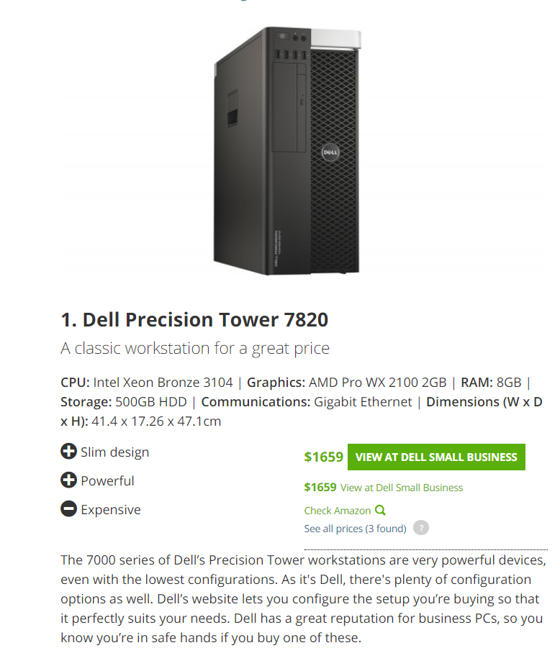

### ***4.1.2* Supporting Development Infrastructure Configuration**

## ***4.2* Quality Assurance Environment**

### ***4.2.1* QA Workstation Configuration**

This goes hand in hand with our server room workstation, that computer will be the one used to test the network to make sure everything is running smoothly and resolve it quickly if there is something wrong

### ***4.2.2* Supporting QA Infrastructure Configuration**

## ***4.3* Acceptance Environment**

*For each environment necessary for system construction (****Development, QA*** *and* ***Acceptance****), provide detailed specifications for the* ***Workstation*** *and* ***Supporting Infrastructure*** *that will be used (including hardware, network and operating system requirements, all necessary installed packages and tools, and needed directory structures**that will be utilized to store all construction components).*

### ***4.3.1* Acceptance Workstation Configuration**

### ***4.3.2* Supporting Acceptance Infrastructure Configuration**